Shell Script Interview Questions

**What is the difference between soft and hard links?**

Soft links are link to the file name and can reside on different filesytem as well; however hard links are link to the inode of the file and has to be on the same filesytem as that of the file. Deleting the orginal file makes the soft link inactive (broken link) but does not affect the hard link (Hard link will still access a copy of the file)

**What is the significance of $#, $ and so on as below**

$0 - The filename of the current script.

Echo $# - shows the count of the arguments passed to the script

echo $? – this tells the status of the last command executed (0 means successfully executed and other number means last command was not successful)

$! - The process number of the last background command

echo $$ - This tell the PID of the current shell

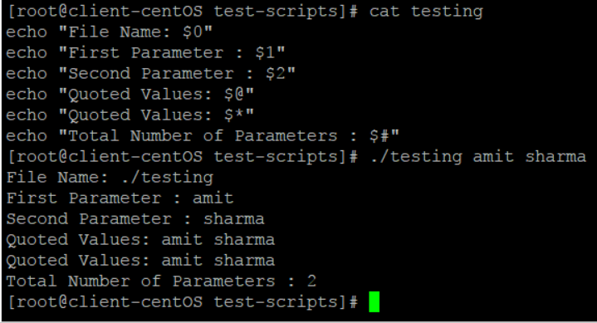

**What is the difference between $$ and $!?**

$$ gives the process id of the currently executing process whereas $! shows the process id of the process that recently went into background

**How will you connect to a database server from linux?**

**What are the 3 standard streams in Linux?**

0 – Standard Input  
1 – Standard Output  
2 – Standard Error

**How to set an array in Linux?**

A=(element1 element2 element3 …. elementn)

**Write down the syntax of “for “ loop**

**Write the syntax for “if”**

# Important Misc commands

**man -k command**

**pwdx PID** (it tells the working directory of PID)

**Sticky bit ( if it is on then only creator of file can delete it no matter what the permission is)**

To add sticky bit

chmod 1777 filename

to remove sticky bit

chmod 0777 filename

**How to compress and decompress a file**

To tar a file or folder

*tar -cvf file_name (this c means create, v means verbose, and f means file)*

untar

*tar -xvf file_name (here x means extract)*

**to gzip a tar file (compress)**

*gzip file_name.tar*

**to decompress**

*gunzip file_name.tar.gz*

**Important** - **here tar only group the files into a single file and does not actually decrease the size(keeps sames size as the actual size)**

**when we do the gzip of the tar file, this actually compress the file)**

**How to do tar and gz in a single command**

**Compress**

tar -zcf file_name ( this converst the file into file_name.tgz (which means file_name.tar.gz)

**To decompress**

tar -zxvf file_name

## Vi Editor Command

dd => delete the current line. If number precedes dd, then those many lines will be deleted. e.g. 10dd will delete 10 lines from current position.  
cc => change entire line  
yy => yank/copy the line in buffer. It can be placed in the file using p option. If number precedes yy, then those many lines will be copied in buffer. e.g. 10yy will copy 10 lines in buffer, which can be put into file anywhere using p.  
cw => change word.  
ce => change word.

:g/^$/d => delete all the blank lines

0 or ^ => to reach the beginning of line

$ => takes you the end of the line

gg => to reach the beginning of the file

G=> to reach end of file  
ZZ => save changes and exit the file.

## PS command

Ps command and top command are same.ps is just the snapshot at one time while top always gets update with refreshed.

ps aux – this gives all the processes with users

top (this command can also be used to kill some process by hitting k and process id)

## File Permissions

**drwxrwxrwx** 4 root root 96 Sep 16 16:19 file_comp

First character represents the directory or file

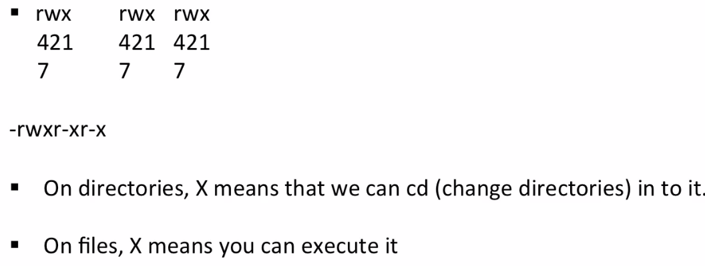

**Symbolic links (sim link)**

Ln –s actual_file link_name